Using a White Cane (and Other Mobility Tools)
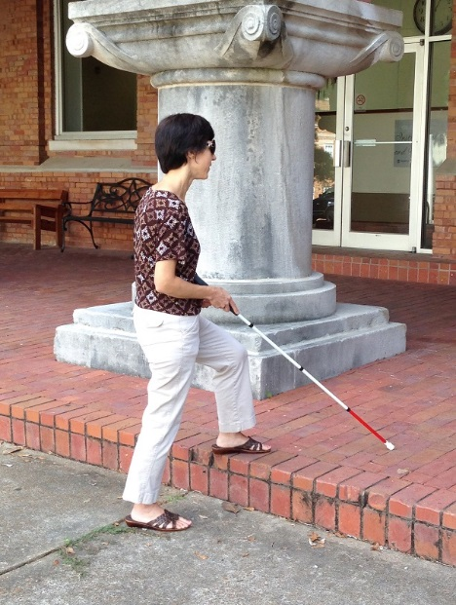
The white cane is the mobility aid most commonly used by persons who are blind or vision impaired. Countless individuals with blindness or low vision use a white cane to help them navigate their environment with greater independence and confidence.

How do I know whether I need a white cane?
A white cane might benefit you if you often find yourself:
- Walking more slowly
- Fearful of tripping over things
- Refusing to go out alone
- Bumping into things and people
- Feeling off balance when walking
- Fearful of falling
- Dragging your feet when you walk
- Feeling unsafe about crossing the street
- Wishing you did not have to depend on others every time you want to leave home

How can I get a white cane?
If you are experiencing these or other problems moving in and around your environment, contact your vocational rehabilitation office and request a referral for O&M evaluation. A skilled O&M specialist can help you decide which mobility tool is best for you. There are a number of techniques and options to improve your safety and comfort that may or may not include a white cane.

Questions?
Contact Kendra Farrow at kfarrow@colled.msstate.edu or (662) 325-8694

